Chicken Curry
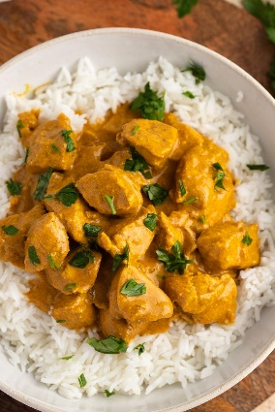

Ingredients
- Chicken – Albertson’s Rotisserie Chicken Breast (chipped into squares).
- Onion and Garlic
- Curry, Cinnamon, Paprika, Bay Leaf, Ginger
- Sugar and Salt
- Tomato Paste
- Yogurt and Coconut Milk
- Lemon Juice
- Cayenne Pepper

Instructions
1. Sauté the aromatics and spices.
Preheat the oil in a skillet over medium heat. Add the onions, garlic, and spices. Stir them for 2 minutes to bring out their flavors.
2. Add the chicken and sauce makings.
Add the chicken, tomato paste, yogurt, and coconut milk to the skillet. Stir the mixture occasionally and let it come to a boil.
Reduce the heat and let it simmer for 20 to 25 minutes. This will allow the chicken to absorb the flavors from the spices and stew.
3. Season it with lemon juice and cayenne.

